**API Testing – ThunderClient**

1. **Register a New User**

* **Method:** POST
* **URL :** http://localhost:8080/api/users/register

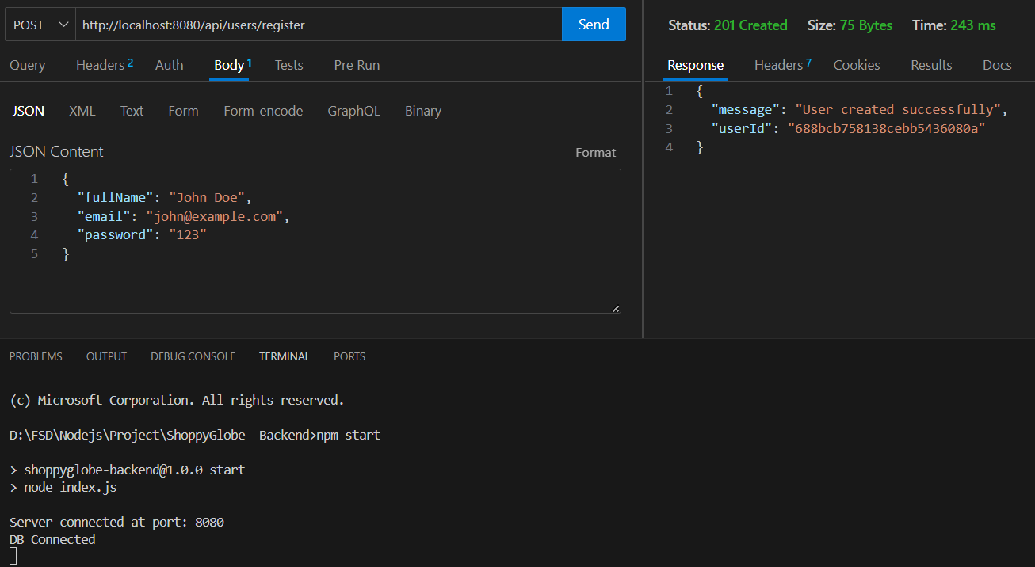

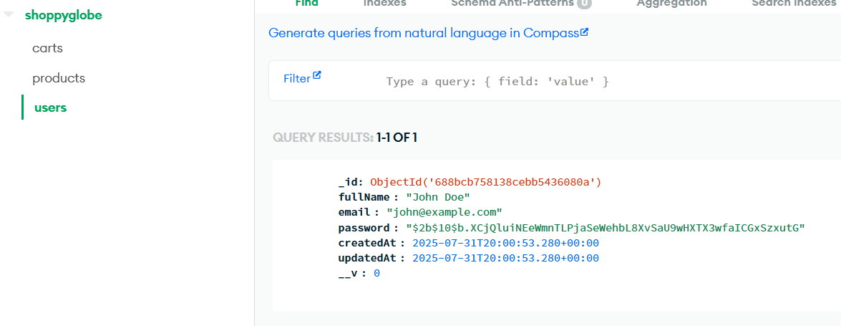

1. **Login with email**

* **Method :** POST
* **URL:** http://localhost:8080/api/users/login

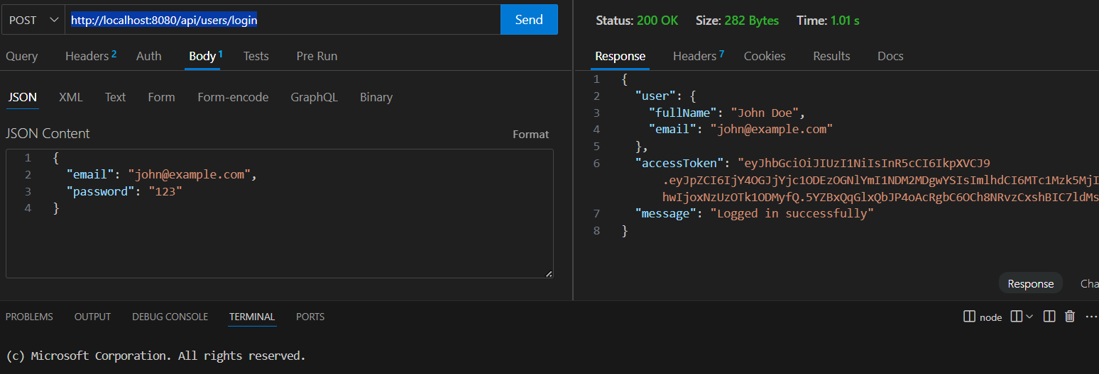

1. **Protect cart routes**

* **Method:** POST
* **URL:** <http://localhost:8080/api/cart>

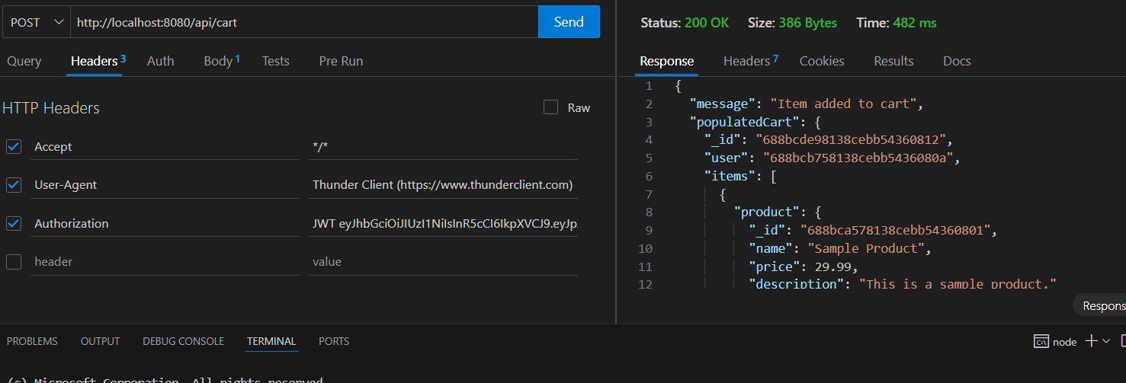

* **Updating cartItem without JWT token**

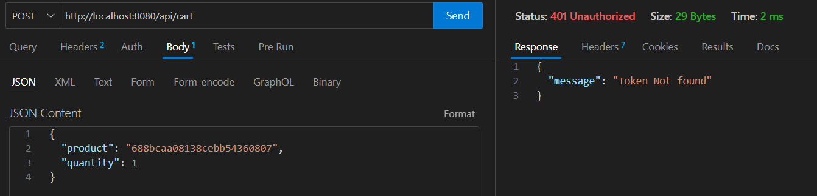

* **Using wrong token id**

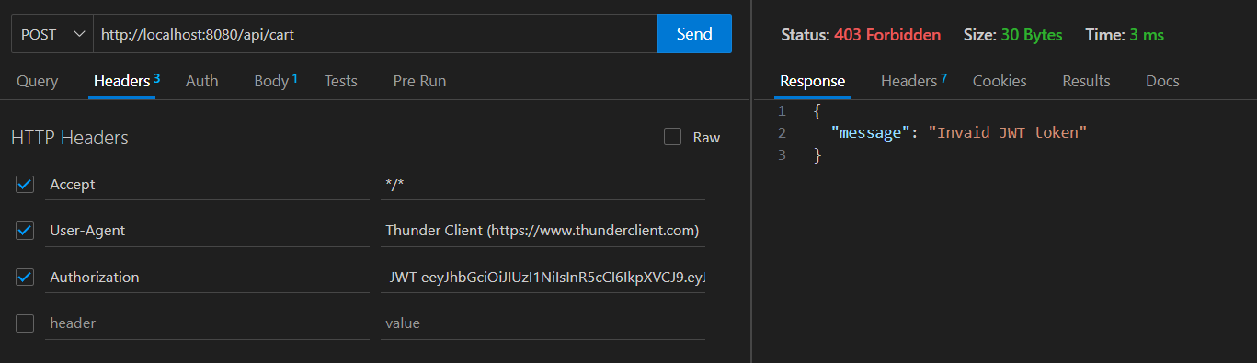

1. **GET products**

* **Method:** GET
* **URL**: http://localhost:8080/api/products

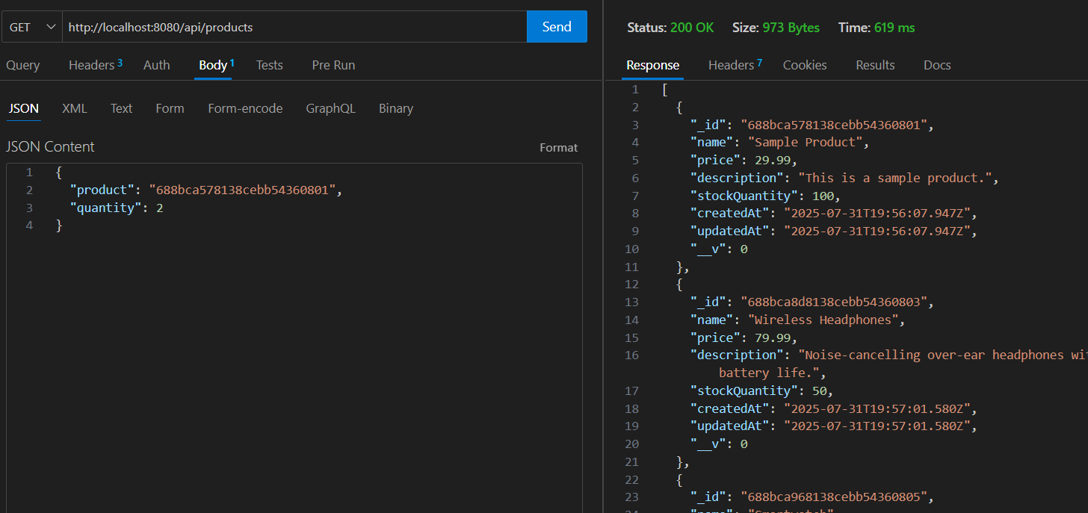

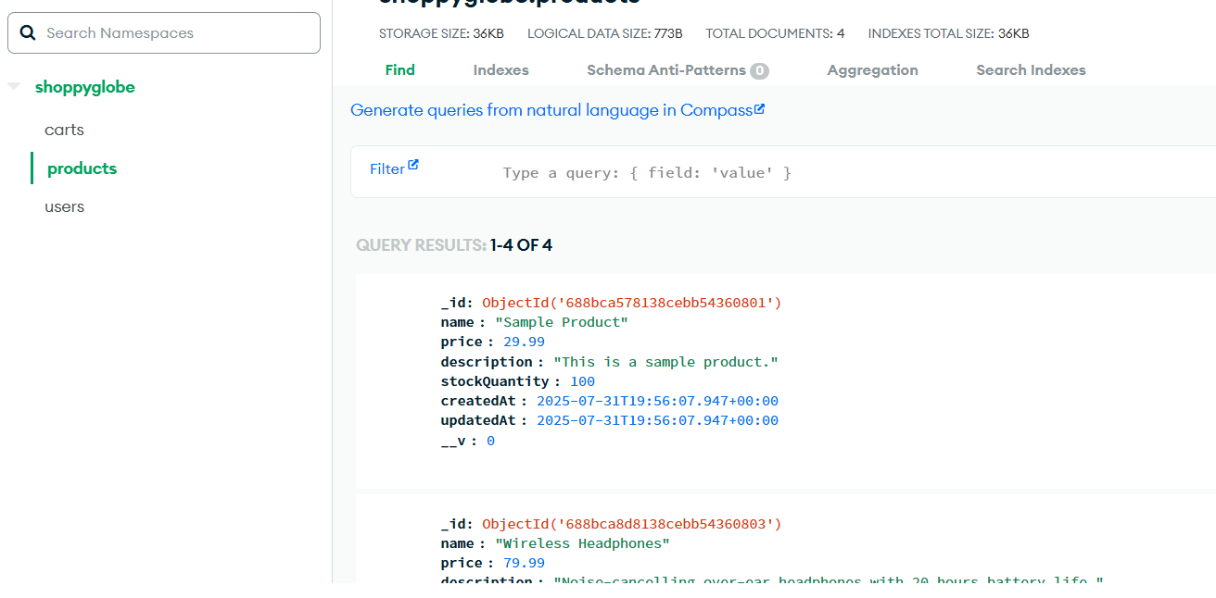

1. **GET products by ID**

* **Method:** GET
* **URL** : http://localhost:8080/api/products/688bca8d8138cebb54360803

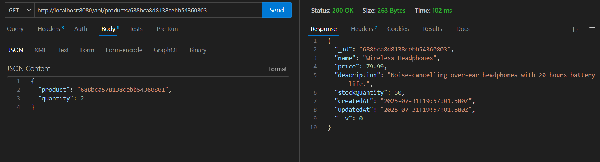

1. **GET product with Invaild ID**

* **Method: GET**
* **URL :** http://localhost:8080/api/products/688bca8d8138cebb54360804

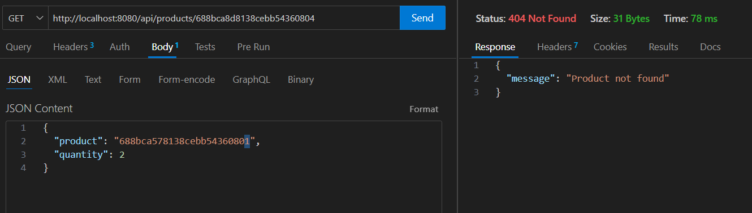

1. **GET Product with wrong format**

* **Method: GET**
* **URL:** http://localhost:8080/api/products/68

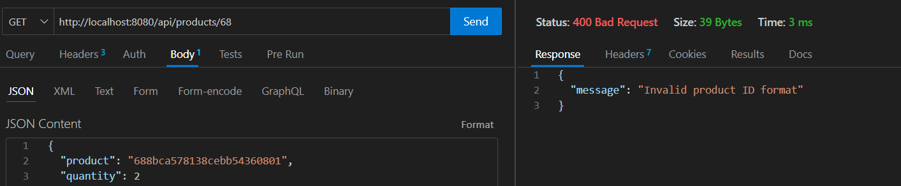

1. **Add products**

* **Method: POST**
* **URL:** http://localhost:8080/api/products

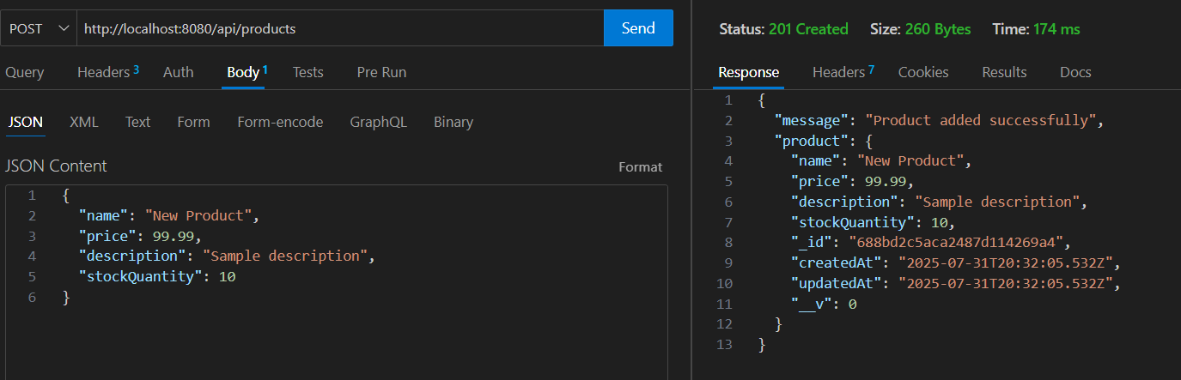

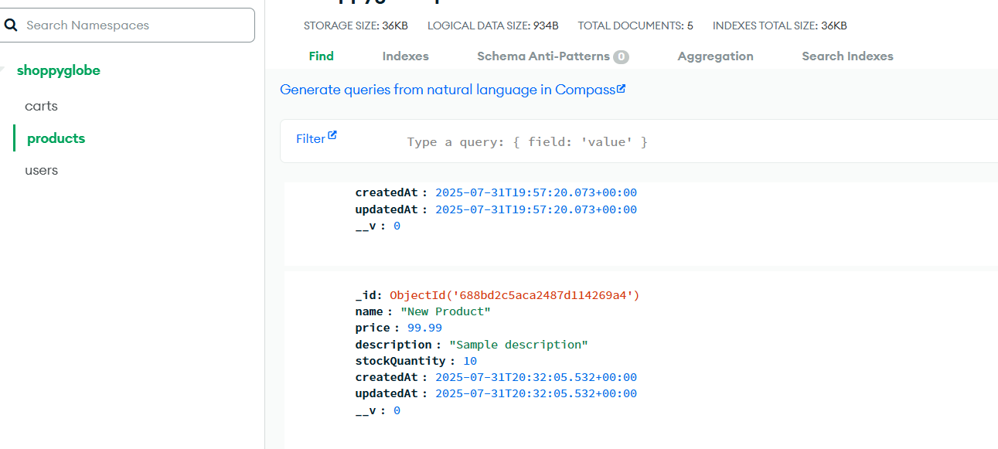

1. **Add CartItem**

* **Method:** POST
* **URL:** http://localhost:8080/api/cart

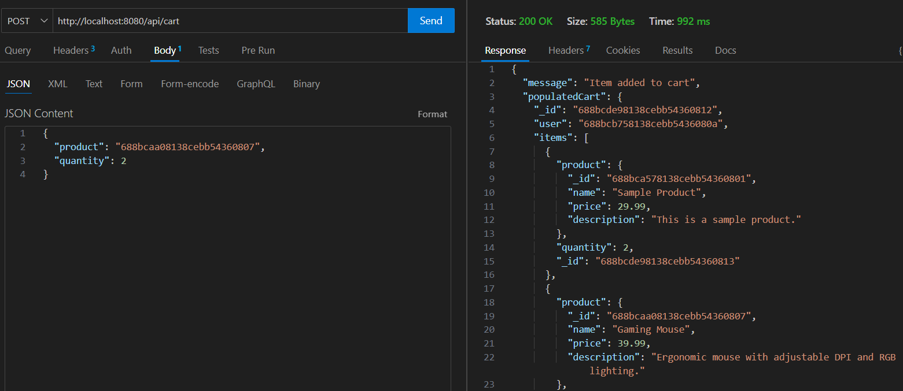

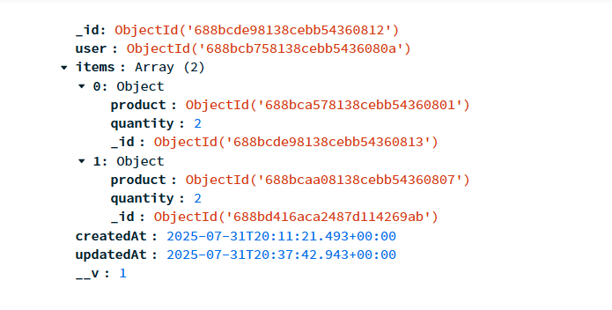

* **With Invalid Product ID**

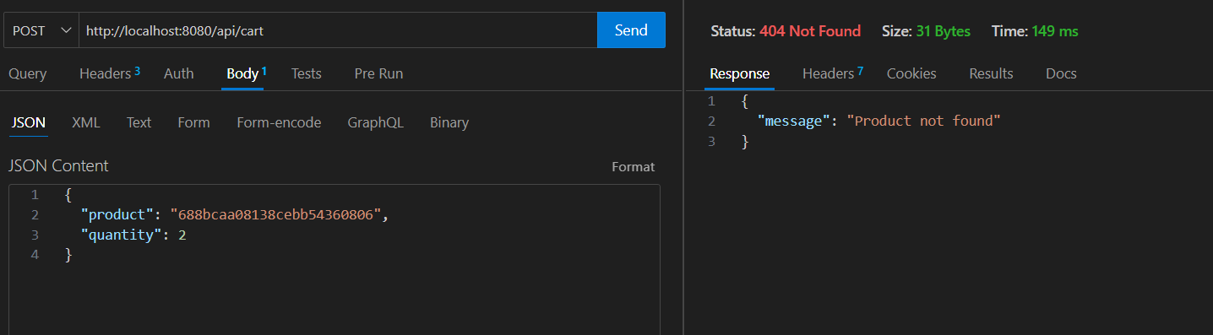

1. **Updating CartItem**

* **Method: PUT**
* **URL:** <http://localhost:8080/api/cart/688bca578138cebb54360801>

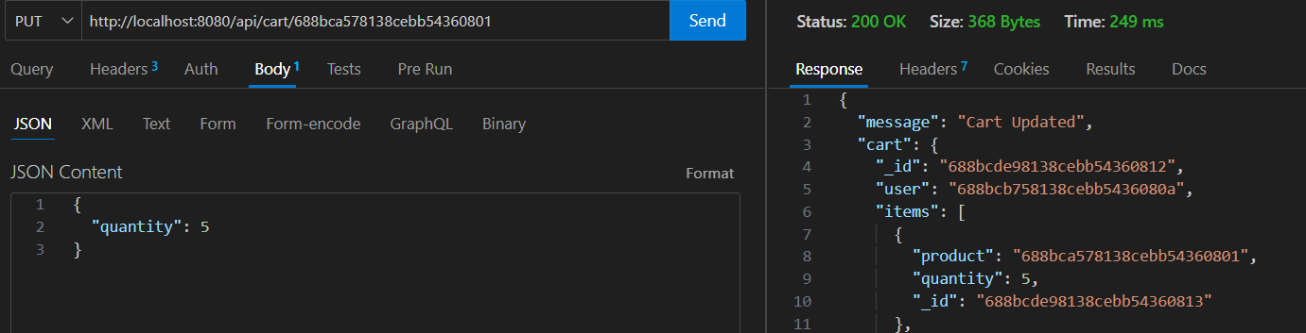

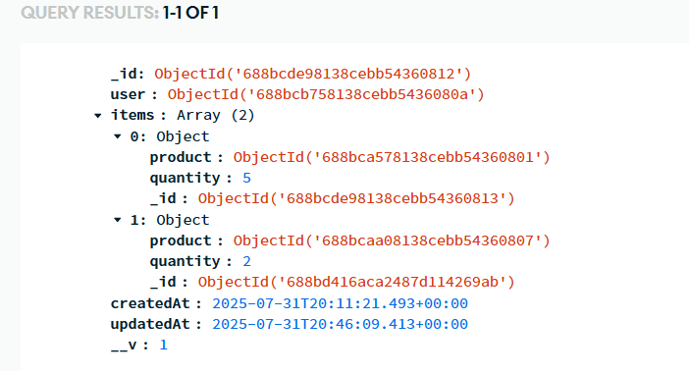

* **With Invalid ID**

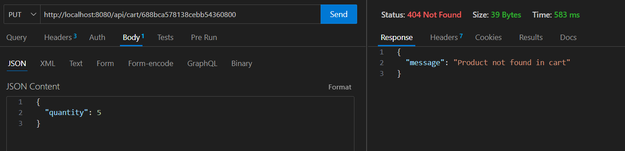

**11.Deleting CartItem**

* **Method:**DELETE
* **URL:** [**http://localhost:8080/api/cart/688bca578138cebb54360801**](http://localhost:8080/api/cart/688bca578138cebb54360801)

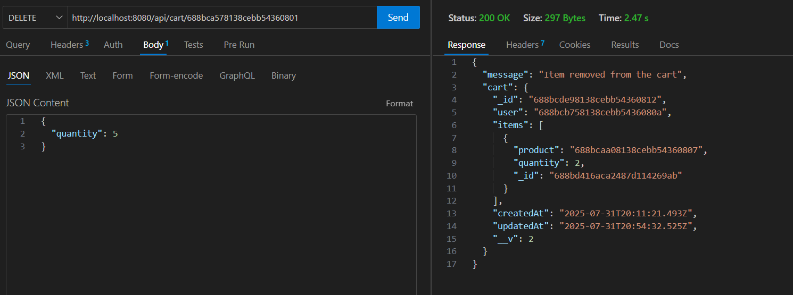

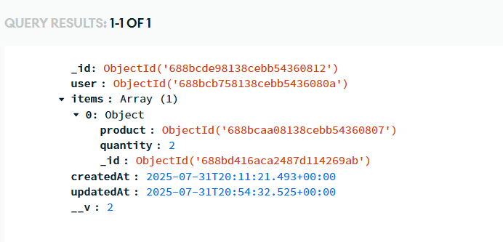

1. **MongoDB shoppyglobe database**

* **Carts collection**

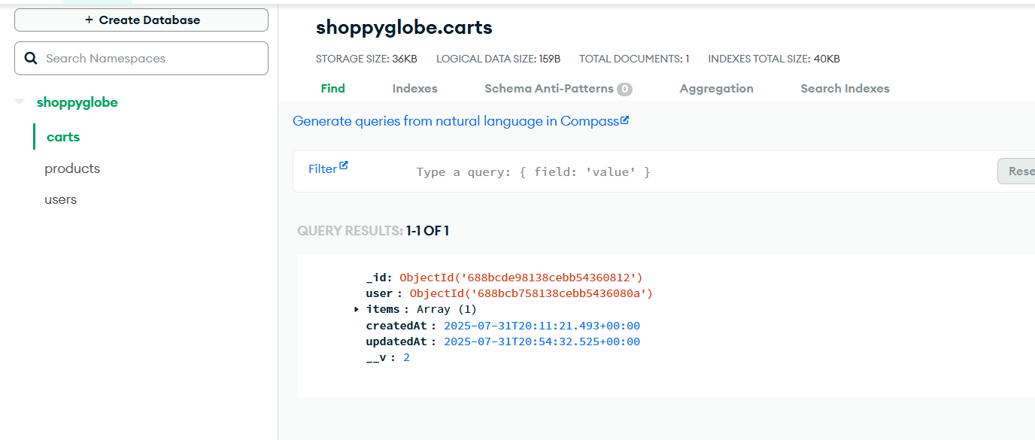

* **Products Collection**

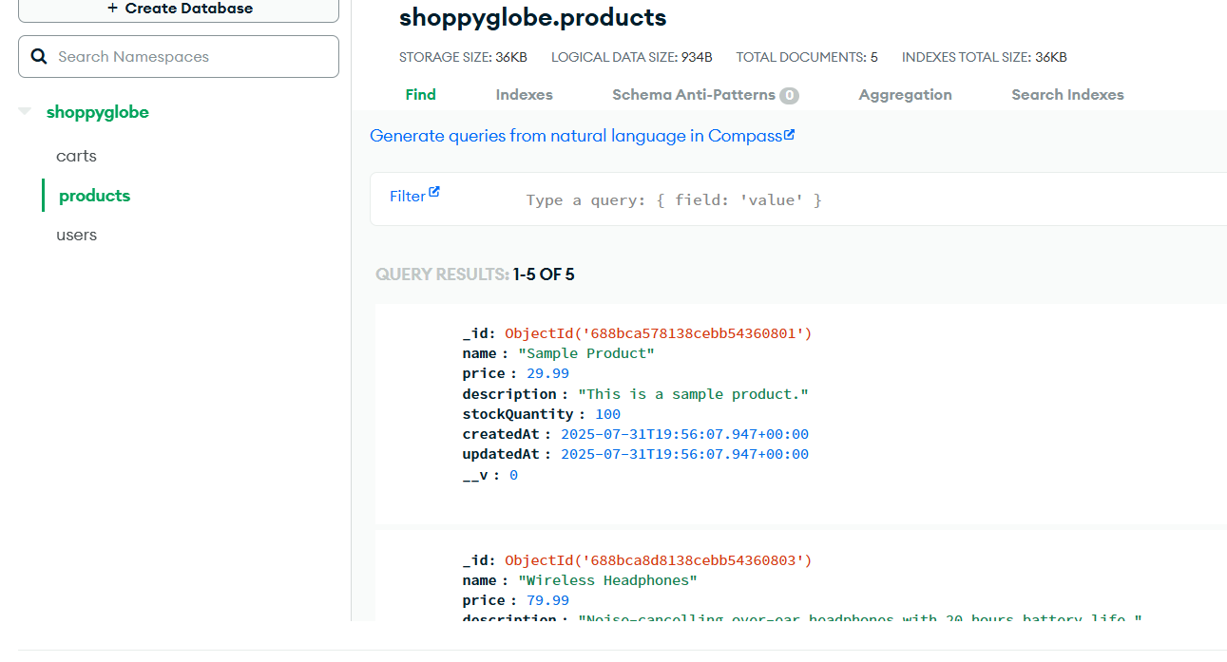

* **Users Collection**

